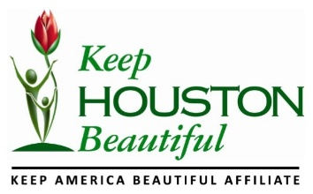
SOCIAL MEDIA AND MARKETING INTERNSHIP
For over 38 years through civic engagement, community collaboration and the work of thousands of volunteers, Keep Houston Beautiful (KHB) has worked to create, enhance and maintain the unique beauty and livability of Houston. Join our efforts in working to keep Houston beautiful.
POSITION
Fall Intern helping for the Mayor’s Proud Partners Luncheon (MPP Luncheon) our annual major event. (Early November - Date to be confirmed)
COMPENSATION
Prefer to hire creative college students who have an interest in PR and can earn academic credit accordingly.
HOURS
Flexible hours to be worked around your school schedule.
JOB DESCRIPTION
Publication
- Write a quarterly publication
- Write a monthly newsletter
- Review flyers and brochures

Social Media writing
- Help engage KHB followers, increase their likes/follows and develop social media campaigns
- Assist in writing, managing and scheduling posts on each platform
- Assist with updating KHB website

Administration
- Data entry
- Respond to phone calls and emails
- File documents
Promotion
- Represent KHB during events (Volunteer fairs, etc.)
IDEAL CANDIDATE
- Familiar with social media platforms Facebook, Twitter, Instagram, and LinkedIn
- Proficient in Adobe CC (InDesign, Photoshop, Illustrator)
- Detail oriented
- Communicates effectively (written and verbally)
- Able to self-manage time and deadlines
REQUIREMENTS
- Must be an undergraduate or graduate student at the University of Houston
- Majoring in: Communication (with a Public Relations, Advertising or Journalism concentration)
- Must be able to work approximately 10 hours/week (flexible)
HOW TO APPLY
Email a completed cover letter and resume to Audrey Laroche at alaroche@houstonbeautiful.org Internship should start by September 2017.

